Table 1.

1- Retrieve properties with balconies, sorted by the number of bedrooms in descending order.

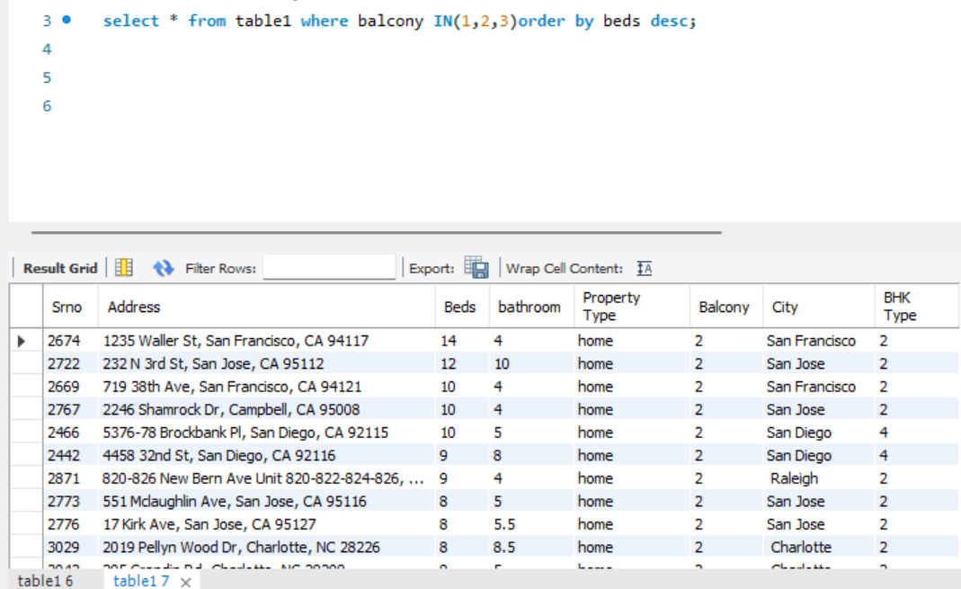

2- Find the top 5 cities with the highest average number of bedrooms per property.

**3-** Count the number of properties in each city.

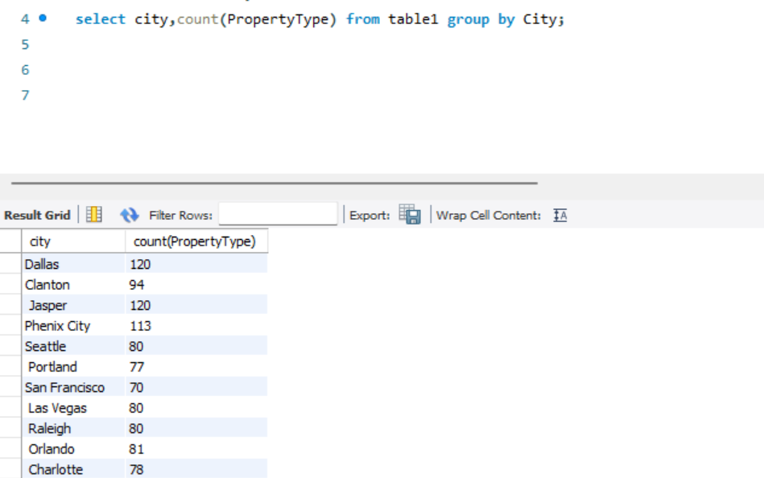

**4-** Retrieve all properties with at least 3 bedrooms and 2 bathrooms.

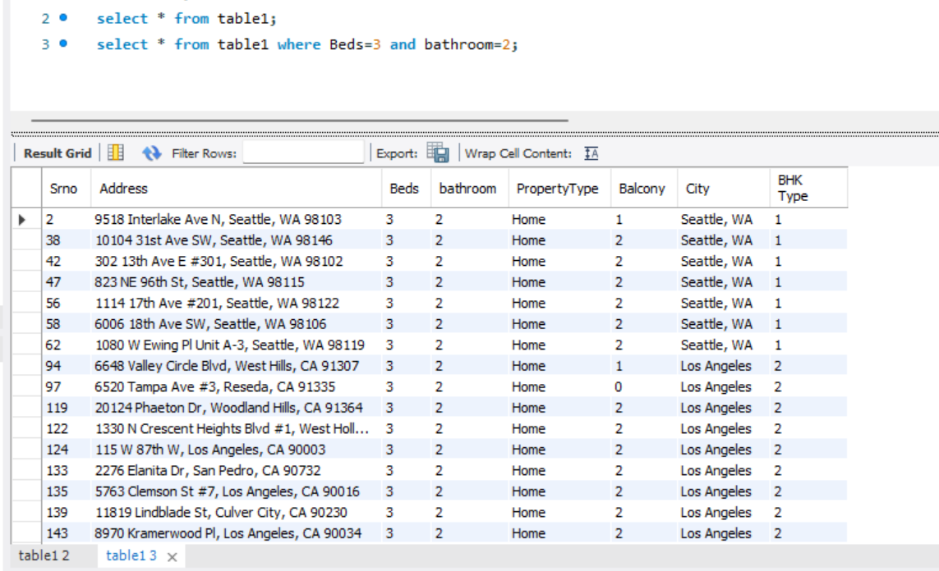

**5-** Find properties in a specific state with a certain landmark. (take state and landmark on your own ).

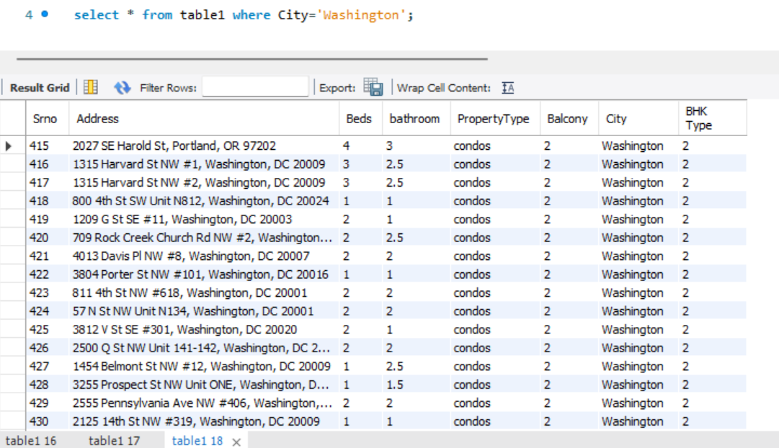

TABLE 2

1. Calculate the average price per square foot for properties built before 2010

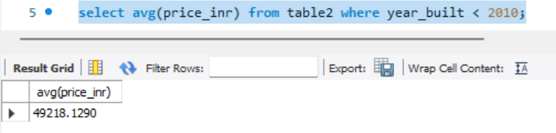

2- Find the total number of properties on each floor.

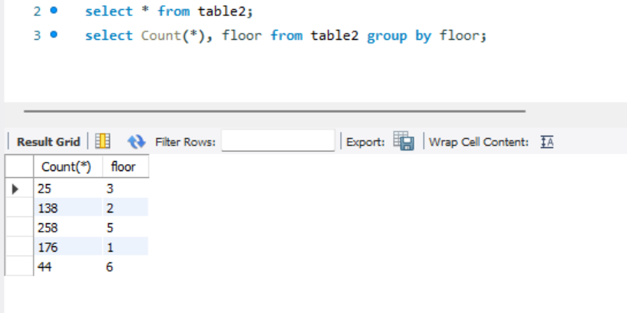

3- Retrieve properties with a carpet area greater than 1000 square feet and a status of 'Under Construction

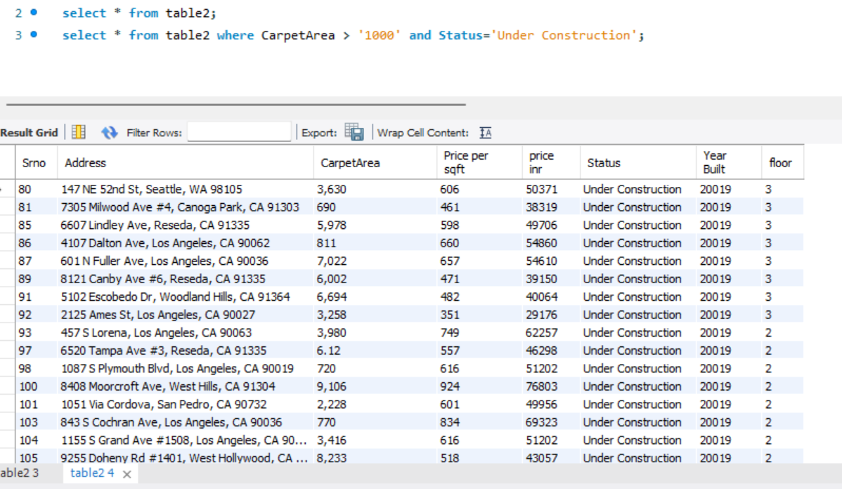

4- Calculate the average price per square foot for each transaction type.

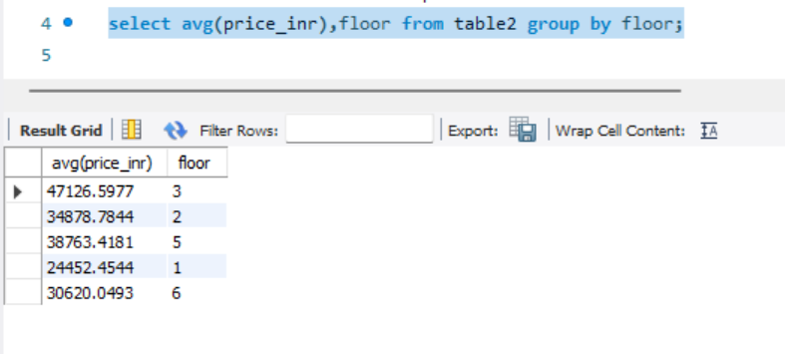

5- Find the properties with the highest price per square foot, sorted in descending order.

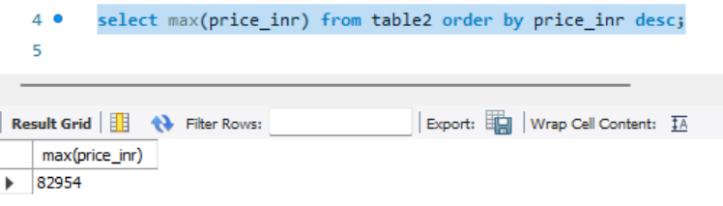

Table 3:

1- Retrieve all properties with a furnished status of 'Fully Furnished' and a facing direction of 'East’

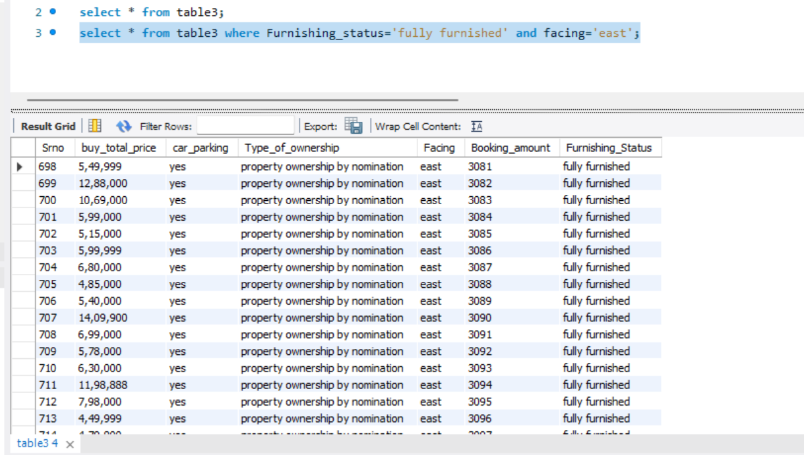

1. Calculate the average booking amount for properties with and without car parking:

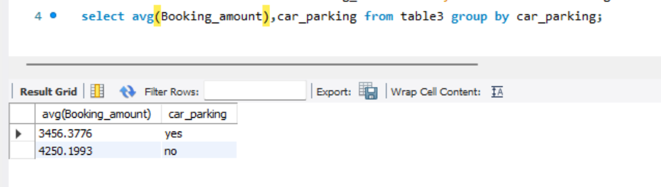

3- Find the total price of properties with different types of ownership.

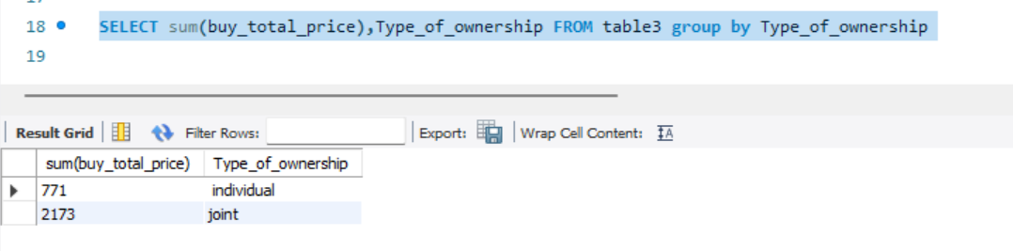

4-Retrieve properties with a booking amount greater than 50000 and a furnished status of 'Semi furnished’.

select * from table3 where Booking_amount >50000 and Furnishing_Status='semi furnished';

5- Find the property with the highest booking amount.

